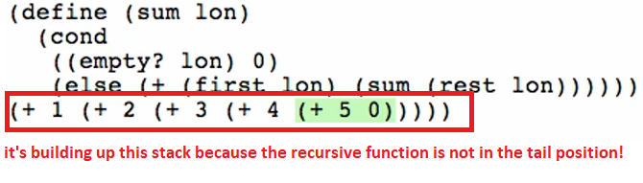

Somehow, we need to make a version of this function **sum** wherein the recursive call will be in the tail position – a tail recursive version of **sum**. We can do that with an **accumulator**.